**Q1**

Display information about files in the current directory



**Q2**

Display the current working directory



**Q3**

Create a new directory



**Q4**

Navigate between folders



**Q5**

Remove empty files from a directory

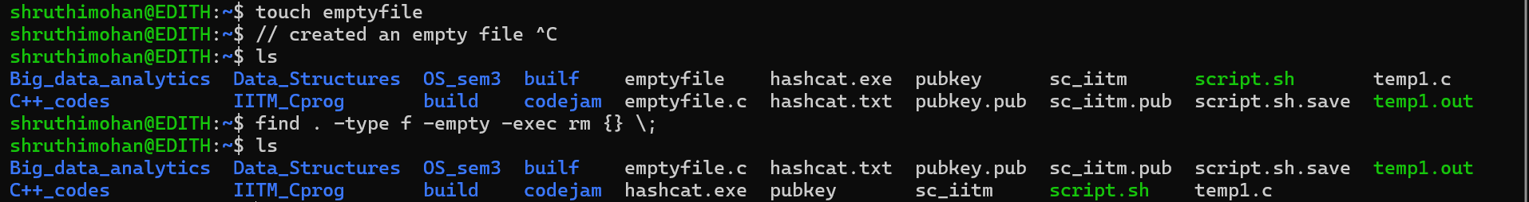

**Q6. a**

Copy files from one directory to the same directory.



**Q6. b**

Copy files to another directory



**Q7. a**

Rename a directory



**Q7. b**

Move a file to a directory



**Q8. a**

Remove a file from a directory

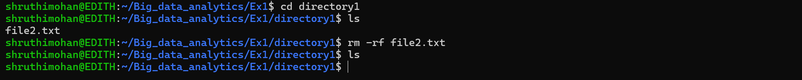

**Q8. b**

Remove a directory containing a few files.

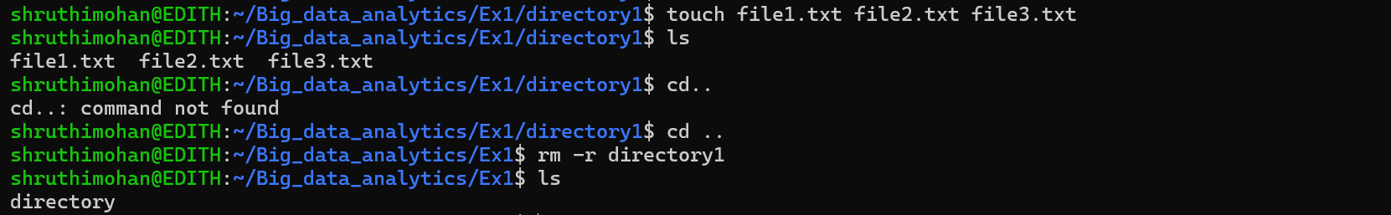

**Q9**

Get basic information about the OS



**Q10**

Find a file in a directory



**Q11**

Create an empty file



**Q12**

Display the contents of a file on the terminal



**Q13**

Clear terminal



**Q14**

Display the processes in the terminal

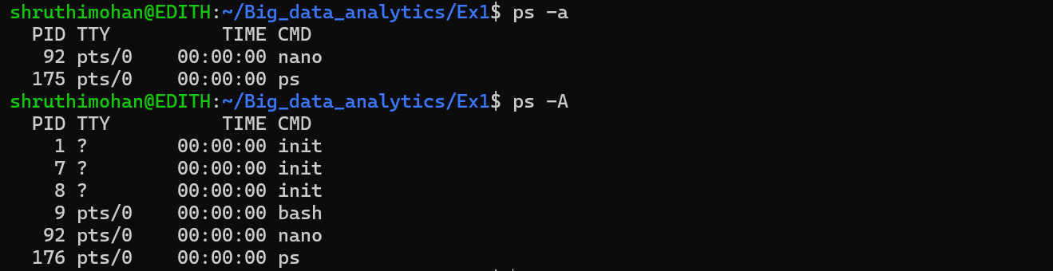

**Q15**

Display list of commands

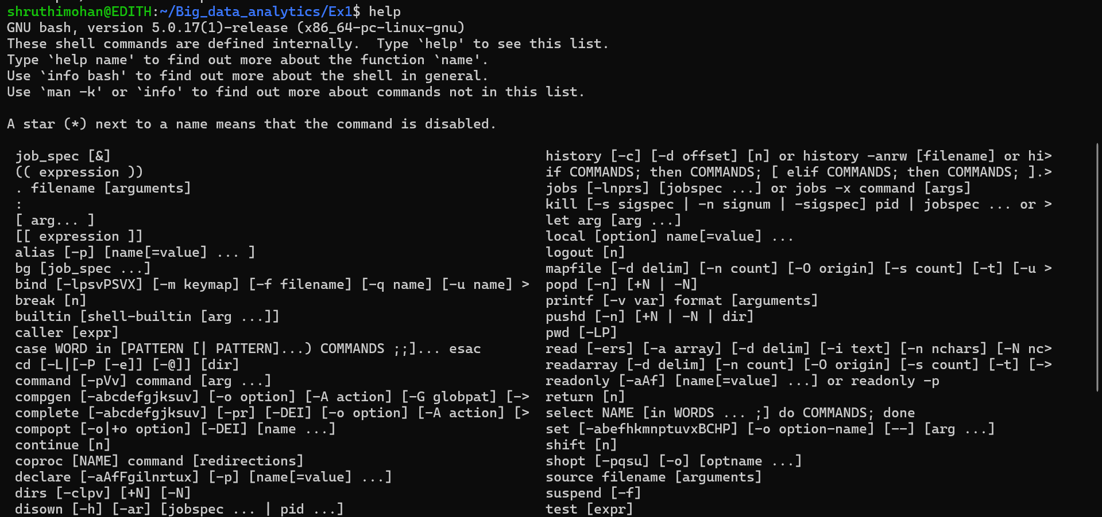

**Q16**

Search for a specific string in output



**Q17**

Display active processes on terminal



**Q18**

Download files from the internet.

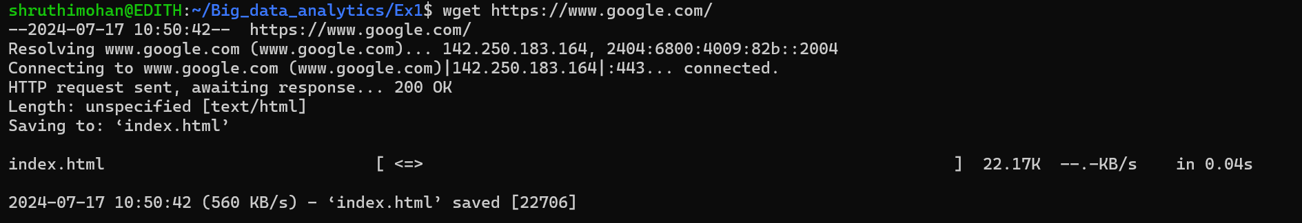

**Q19**

Create or update passwords for existing users



**Q20**

View the exact location of any tool/software installed



**Q21**

Check the details of the file system

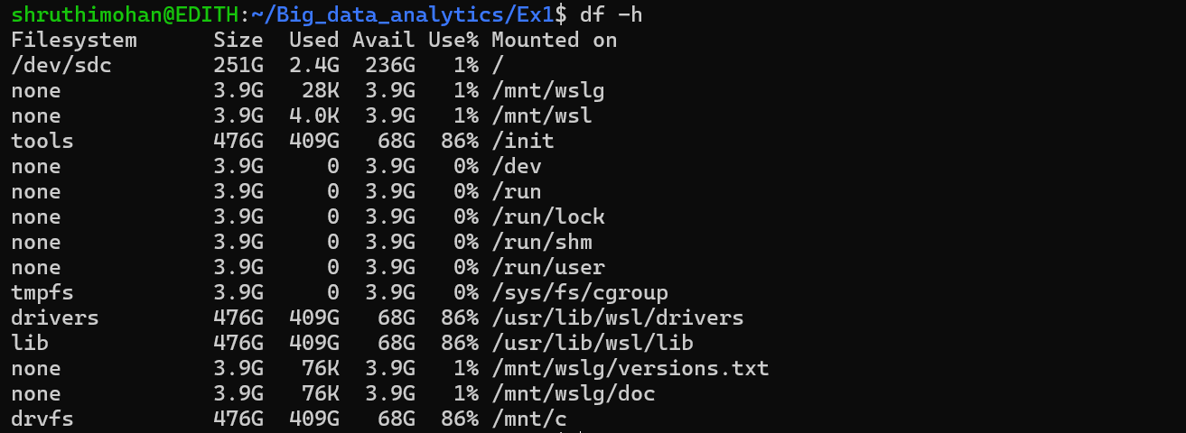

**Q22**

Check the lines, word count, and characters in a file using different options

